Tacts Prototype's and Class Diagram

Tacts is a address book program with support for grouping contacts.

Main UI:

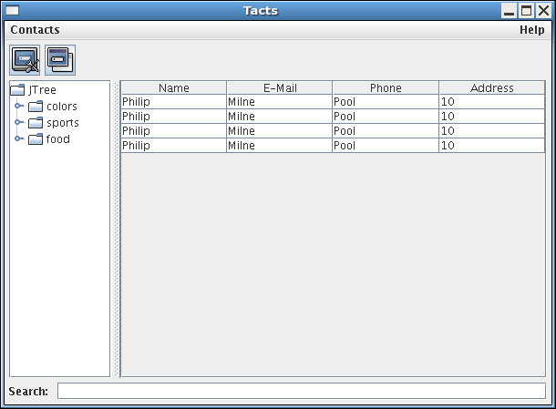

Add Contact Dialog:
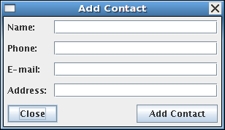

Add Group Dialog:

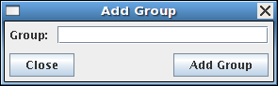

About Dialog:

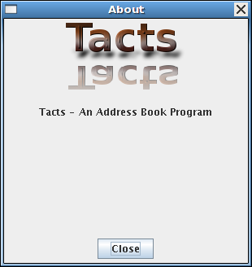

Class Diagram:

